

Digital Marketing Proposal

Desire Technologies
www.desiretech.com

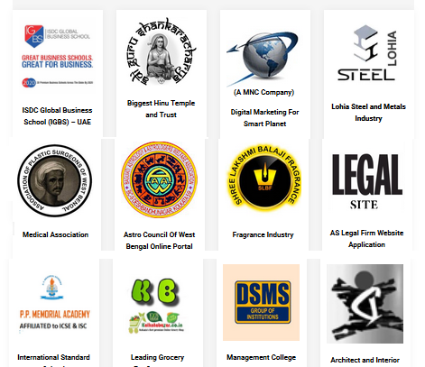

----------------------------------------------------------------------------------------------------------------------------------------------


Desire Technologies
www.desiretech.com | +91-9830682298 | +91-33 3554 2842

106/2B Raja Ram Mohan Roy Sarani,Kolkata-700009,West Bengal,India
152 – 160 City Rd, London EC1V 2NX, United Kingdom

1 | P a g e

We at Desire Technologies are committed to provide you the best solution in digital marketing and also best support in the industry.

Desire Technologies is a web design, Development and Digital Marketing Company. We have expertise in web design, web development, ecommerce, Search Engine Optimization (SEO), Search engine marketing (SEM), Social Branding and online marketing solutions. Our online marketing strategies ensure the maximum exposure of your website.

Why a Web Site Needs Search Engine Optimization

The increased visibility which results from a properly well thought-out SEO optimization campaign boosts your website's ability to be found by searchers seeking your services. This increase in targeted traffic to your site greatly increases the likelihood of sales.



Our search engine optimization process can be described through as below



Off-Page Optimization

- Link Building
- Directory Submission
- Article Submission
• Product Directory Submission Step 3:

- Social Book Marking Services
- Press Release


On-Page Optimization

- Optimizing Title Tags & Meta Tags
- Optimization Site Directory and structure, Navigation
- Anchor Tag Optimization
• Existing Content Optimization Step 2:

- Creation of new Optimized pages

- Image Optimization


Site wide Factors

- Preparing a detailed SEO Strategy
- Basic Keyword Research and identification
- Competitors analysis and report preparation
• Site change implementation Step 1:

- XML Sitemap
- RSS feeds
- Website Traffic Analysis

Desire Technologies
www.desiretech.com | +91-9830682298 | +91-33 3554 2842

106/2B Raja Ram Mohan Roy Sarani,Kolkata-700009,West Bengal,India
152 – 160 City Rd, London EC1V 2NX, United Kingdom

2 | P a g e

We would be performing below task monthly for each website:-

Domain (www.yourcompany.com) If you don’t have it .
Google My Business Listing GMVT If you Don’t Have It
How We Promote | Weekly Posting (Approx) | Monthly Posting (Approx)
Digital Banner Creation | 3 | 10
Video Promo Ad For Holidays and Special Event |  | 3
Video Review and Testimonial |  | 2
Social Bookmarking | 2 | 6
Directory Submission | 1 | 4
Search Engine Submission | 1st month only
Classified |  | 5
Business Listing |  | 2
RSS feeds submission | As per Required
URL Pinging | As per Required
Blog Creation & posting | 2 in a week | 8
Forum | 1 in a week | 3
Article | 2 in a week | 8
Article Bookmarking | 1 | 4
Blog Bookmarking | 1 | 4
Press Release submission | Provided by client
Question & Answering | Quora and Others Site | 4
Social Profile creation |  | 2
Facebook Posting | 15 in a month (Like Follower 40 Increase )
Twitter tweet | 15 in a month (Like Follower 40 Increase)
Whatsapp Banner Video | 16 in a month(Like Follower 40 Increase)
Instagram Banner | 17 in a month(Like Follower 40 Increase)
LinkedIn Posting | 18 in a month(Like Follower 40 Increase)
Snapchat | 19 in a month(Like Follower 40 Increase)
Pinterest Channel Promotion | 20 in a month(Like Follower 40 Increase)
Youtube Video |  | 2
Vimeo Video |  | 2
Justdial Sulekha and Others Local Business Listing Review |  | 4
Google My Business Review | 2 | 10
Increase people talking about.
Email Blasting |  | 25
Bulk SMS Blasting |  | 100
Tele Calling |  | 20
Continued below SMO Strategy:
PPC Will Cost Extra as per Budget Charge Given Below

Desire Technologies
www.desiretech.com | +91-9830682298 | +91-33 3554 2842

106/2B Raja Ram Mohan Roy Sarani,Kolkata-700009,West Bengal,India
152 – 160 City Rd, London EC1V 2NX, United Kingdom

3 | P a g e


SMO Strategy



- Creation and submissions strategic content (Include profiles, business listings, articles, press releases, blog posts)

- Optimize all content for SERPs, populate and promote exist social assets as well as new ones created using a mix of SEO, content and social media strategies.

- Development of Micro Sites.

- Increase genuine likes and followers in Social Media Profiles (Facebook, Twitter, LinkedIn, Flickr, and YouTube).

- Social Bookmarking and increase voters.
- Setup, Linking & Promotion of Profiles

- External Blog Setup & Social Commentary

- Wikipedia Profile Setup & Linking

- Photo Sharing
- Slide share Submission

- Create Blog with our main domain name and share it in social account.

- Explore Guest Posting

- Tracking and monitoring our Reputation of with our main keywords that represents our brand.

- Evaluate Your Competition

- Focus where we can get the best results (like social bookmark).
- Search relevant forums and start discussion over there.

- We will change our social accounts banner every month (Facebook, Twitter, and LinkedIn) and when we launch any new thing we will create a banner like that and change it.

- Info graphic Submission.

- Grow our YouTube channel subscriber & viewers.

- Create more channels like Vimeo, MySpace etc. and expand our video in other channels.

- Online forums and communities Discussion


Desire Technologies
www.desiretech.com | +91-9830682298 | +91-33 3554 2842

106/2B Raja Ram Mohan Roy Sarani,Kolkata-700009,West Bengal,India
152 – 160 City Rd, London EC1V 2NX, United Kingdom

4 | P a g e

Cost for Digital Marketing (SEO + SMO):

 | No. of Keywords |  |  | Service |  |  | Fees per month
 | 5 keywords |  |  | SEO + SMO |  |  | RS .9999
 | 10 keywords |  |  | SEO + SMO + |  |  | RS .19999
 | 20 keywords |  |  | SEO + SMO |  |  | RS .49999
 | 30 keywords |  |  | SEO + SMO |  |  | RS .1 Lacs
 | And so on

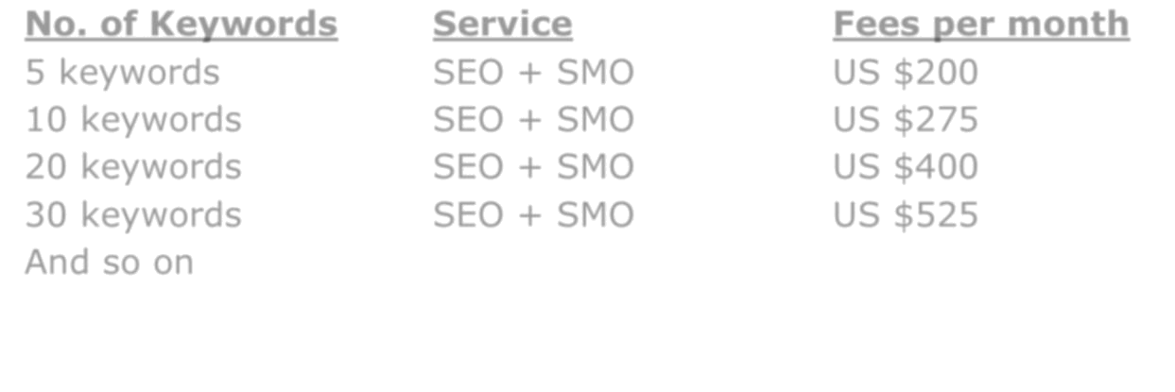

1. Time Frame to achieve Page one ranks:

- Low Competition keywords: 3-7 Months
- Medium Competition keywords: 5-9 Months

- High Competition keywords: 8-12 Months

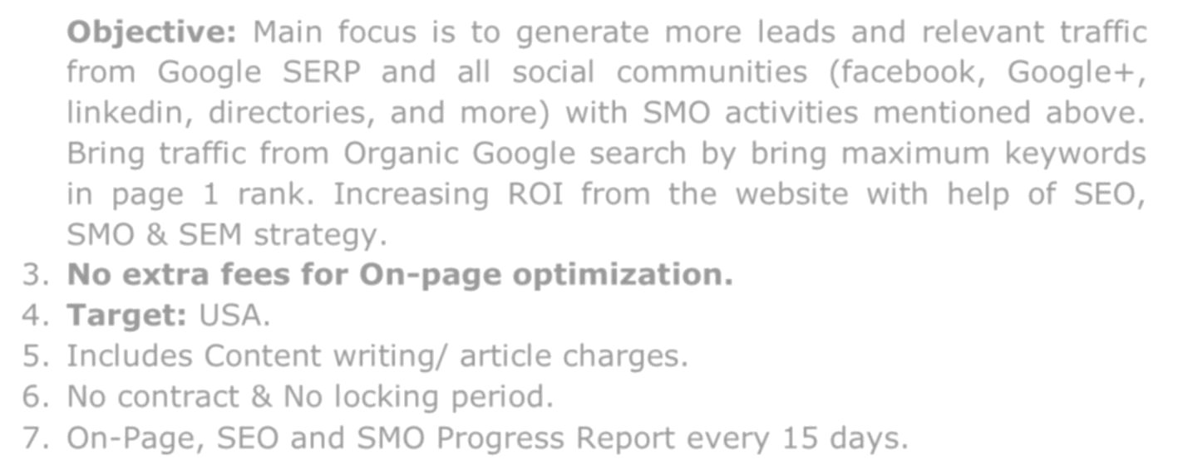

- Objective: Main focus is to generate more leads and relevant traffic from Google SERP and all social communities (facebook, Google+, linkedin, directories, and more) with SMO activities mentioned above. Bring traffic from Organic Google search by bring maximum keywords in page 1 rank. Increasing ROI from the website with help of SEO, SMO & SEM strategy.

- No extra fees for On-page optimization.

- Target: INDIA.

- Includes Content writing/ article charges.

- No contract & No locking period.

- On-Page, SEO and SMO Progress Report every 15 days.

Desire Technologies
www.desiretech.com | +91-9830682298 | +91-33 3554 2842

106/2B Raja Ram Mohan Roy Sarani,Kolkata-700009,West Bengal,India
152 – 160 City Rd, London EC1V 2NX, United Kingdom

5 | P a g e


Recommended Add-on SEM Strategy

Recommended Budget for SEM:

- PPC Ads for Branding & Traffic (initially recommended budget Rs.30000)

- Social Media Ads including Facebook ads (initially recommended budget Rs.9500)

What is PPC?

Pay-per-click (also known as CPC) is where an advertiser pays for their copy/advertisement, Ad, to appear when you search your keywords. A simple and effective way of getting almost instant traffic is by paying for it. When our clients ask us to define Pay Per Click, we tell them that PPC is a very cost-effective means to get their site noticed by their target audience while our other Internet marketing strategies are gradually helping their site achieve their natural ranking potential.

In a way, PPC advertising works like a silent auction. Advertisers place bids on keywords or phrases that they think their target audience would type in a search field when they are looking for specific goods or services. When a web user types a search query into the field of a search engine that matches the advertiser’s keyword list or visits a web page with content that correlates to the keywords or phrases chosen by the advertiser, the PPC ad may be displayed on the page. In search engines, a PPC ad is generally just above or to the right of the search results where they can be easily seen. On other kinds of websites, the ad will be placed in the location that the site designer has determined will be the most advantageous to his site and the advertiser.

To differentiate PPC ads from the natural search results displayed on a page, search engines will often place PPC ads under “Sponsored Ads” or “Sponsored Links” which also makes them easier to notice on a page that is crowded with text and other items competing for a web user’s attention.

The rates that these outfits charge for a PPC ad vary significantly depending on the popularity of the keyword or phrase. For example, if an advertiser wants a PPC ad targeted for the phrase ‘cottage cheese’, they can get prominent placement for their PPC ad with a very low bid and a low per-click charge. However, for a phrase such as ‘computer’, an advertiser can expect heavy competition for prominent placement

Desire Technologies
www.desiretech.com | +91-9830682298 | +91-33 3554 2842

106/2B Raja Ram Mohan Roy Sarani, Kolkata-700009,West Bengal,India
152 – 160 City Rd, London EC1V 2NX, United Kingdom

6 | P a g e

and expect to pay premium per-click rates. It all comes down to supply and demand for the keywords and phrases that the advertiser wishes to target.

The Ad will appear in one of the following positions:

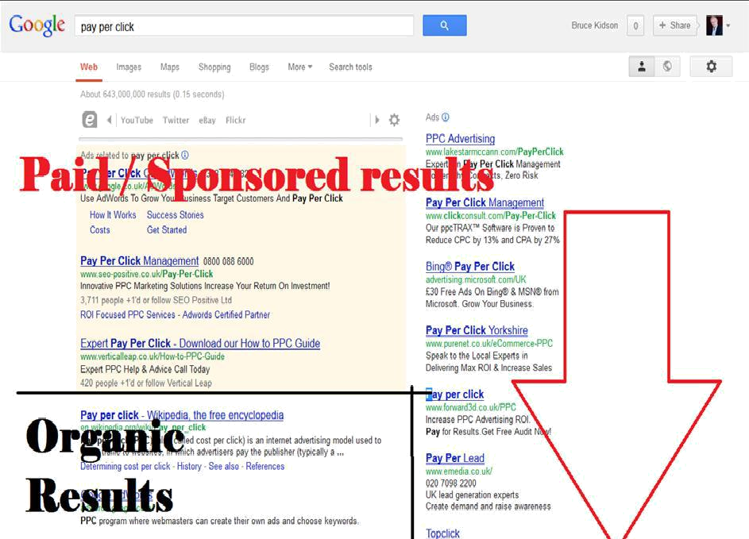

Benefits of Pay Per Click (PPC)?

PPC advertising is a powerful and responsive method for generating immediate targeted traffic for your business as it gives you high return on your investment. It is an important part of internet marketing which can be done with a pre-set budget and it also allows conversion rate tracking.
- Results come in quick

- Cost is easy to control

- You decide what words to bid on

- You write the ads

- Changes are easy to make and upload fast

- There’s an on/off switch

- No contracts

- There is customer service/tech support for most issues

- It can be the cheapest form of advertising

- Visitors are a targeted user- they searched for you!

Desire Technologies
www.desiretech.com | +91-9830682298 | +91-33 3554 2842

106/2B Raja Ram Mohan Roy Sarani,Kolkata-700009,West Bengal,India
152 – 160 City Rd, London EC1V 2NX, United Kingdom

7 | P a g e

PPC Account Structure

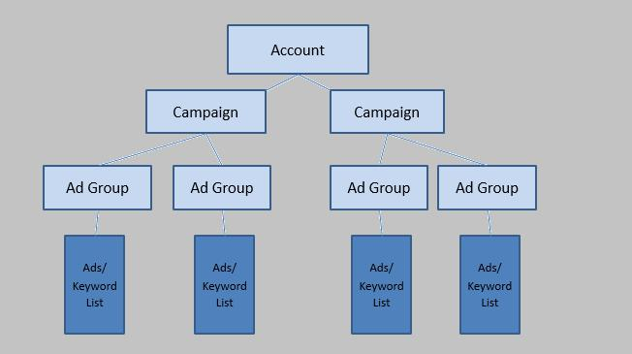

Campaign Set Up:

The campaign is the vessel for your ad groups and where most of the settings are. Budget, geography, networks, negative keywords, time of day/days of the week and devices.

Ad Groups:

Use the keyword niches you plan on targeting to determine how many and which ad groups you’ll need to create.

Writing Ads:

- Make the message in the ad match the message on the landing page.

- Write for your audience

- Use a keyword from your list in the headline and in the body

Cost for Google PPC and Facebook ads campaign(if required):

- PPC Campaign Setup: Rs.2000 one time.

- PPC Campaign Running fees per month (Google, Youtube, Bing, Gmail, Linkedin, Twitter): 30000 per month up to budget of 450,000.

- Facebook & Instagram ad Campaign Setup: 1000 one time.

- Facebook ads Campaign Running fees per month: 2000 per month up to budget of 20000.

Desire Technologies
www.desiretech.com | +91-9830682298 | +91-33 3554 2842

106/2B Raja Ram Mohan Roy Sarani, Kolkata-700009,West Bengal,India
152 – 160 City Rd, London EC1V 2NX, United Kingdom

8 | P a g e

